**Experiment No. 3-Implementation of Fuzzy Set Operations: Union, Intersection, and Complement**

**Aim:** To demonstrate and implement fundamental operations on fuzzy sets: union, intersection, and complement.

**Learning Objective:** To understand and apply basic fuzzy set operations to handle uncertainty in data analysis.

**Tools:** Python 3 language and IDLE

**Theory:**

**Fuzzy Sets:** A fuzzy set is a mathematical model used to represent and handle uncertainty and vagueness in data. Unlike classical sets, where membership is binary (either an element is a member or not), fuzzy sets allow for partial membership, where each element has a degree of membership ranging from 0 to 1. This degree indicates the extent to which an element belongs to the set.

**Fuzzy Set Operations:**

1. **Union:**
   * The union of two fuzzy sets combines their elements, where the degree of membership in the resulting set is the maximum of the degrees of membership from the original sets. This operation captures the idea that if an element belongs to either of the fuzzy sets, its membership degree in the union set will be as high as it is in either of the original sets.
   * Mathematically: $μ_{Y}\left(x\right)=max⁡(μ_{A}\left(x\right),μ_{B}\left(x\right))$
2. **Intersection:**
   * The intersection of two fuzzy sets combines their elements, where the degree of membership in the resulting set is the minimum of the degrees of membership from the original sets. This operation represents the idea that an element’s membership in the intersection set is limited by its membership in the least inclusive of the original sets.
   * Mathematically: $μ_{Y}\left(x\right)=min⁡(μ_{A}\left(x\right),μ_{B}\left(x\right))$
3. **Complement:**
   * The complement of a fuzzy set represents the negation of membership, where the degree of membership in the resulting set is calculated as 111 minus the degree of membership in the original set. This operation reflects the concept of the "absence" of membership to the fuzzy set.
   * Mathematically: $μ_{Y}\left(x\right)=1-μ_{A}(x)$

These operations are essential in fuzzy logic and are used to model and reason about systems where information is not precisely defined or is subject to varying degrees of uncertainty.

**Code & Output:**

1. Union : In the union operation, we correctly use the maximum degree of membership:

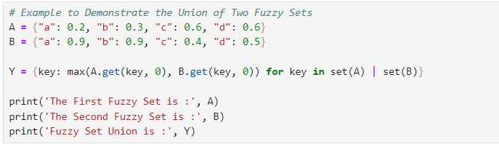

This code ensures that you handle cases where keys may be missing in either set, using get() with a default value of 0. The output will be:

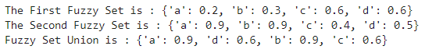

2. Intersection : For intersection, we use the minimum degree of membership correctly:

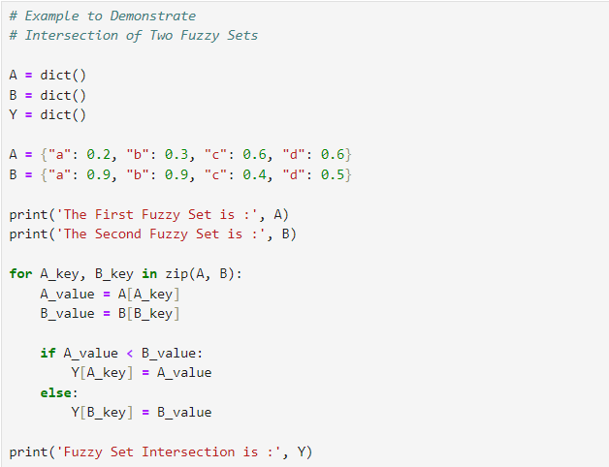

using get() with a default value helps manage missing keys. The output will be:



3. Compliment :

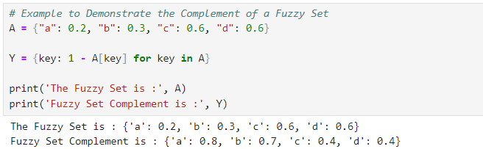

**Learning Outcomes:** The student should have the ability to

LO3.1: Understand and apply the concept of fuzzy sets and their operations, including union, intersection, and complement.

LO3.2: Implement these operations using Python to effectively compute and analyze fuzzy set intersections and complements.

**Course Outcomes:** Upon completion of the course, students will be able to understand

CO3.1: Understand and apply fuzzy set operations (union, intersection, and complement) to handle and analyze uncertainty in data.

CO3.2: Implement basic fuzzy set operations using Python to perform calculations and interpret the results in practical scenarios.

**Conclusion:**

____________________________________________________________________________________________________________________________________________________________________________________________________________________________________________________________________________________________________________________________________________________________________

|  |  |  |  |  |
| --- | --- | --- | --- | --- |
| **Correction** | **Formative** | **Timely** | **Attendance /** |  |
| **Parameters** | **Assessment** | **completion of** | **Learning** |
|  | **[40%]** | **Practical [ 40%]** | **Attitude** |
|  |  |  | **[20%]** |
| **Marks** |  |  |  |
| **Obtained** |

For Faculty Use